Hardware Health — Product Brief
Generated by /nucleus-plan-ado from the discovery workbook. The brief covers Sections 1 (Product Brief) and 2 (Process Map). The detailed troubleshooting flow lives in Appendix A (full-page diagram); the Feature / Story breakdown lives in Appendix B (full-page table). The engineering-facing AZDO (Azure DevOps) import template is in the sidecar `<workbook-stem>_azdo-template.csv` — not in this document.

1. Product Brief
Workstream: Hardware Health
Problem Statement: Power-supply alerts on Cisco access switches are frequent and noisy, and every one is triaged by hand today. Engineers spend 15-20 minutes per alert on the CLI confirming whether a PSU (Power Supply Unit) has genuinely failed, whether redundancy is lost, or whether the event was a transient blip - and transient events often sit open for hours before anyone closes them.
Additional Comments: MVP (Minimum Viable Product) scoped to Cisco Catalyst 9200 / 9300 access switches, standalone and stacked. Covers PSU failure or removal, lost power redundancy, input-feed loss, PoE (Power over Ethernet) budget exhaustion and flapping supplies. Modular / chassis platforms are out of scope for the MVP. The agent runs read-only show commands - it makes no configuration changes.
Process Owner: Network Operations Lead
Success KPIs (Key Performance Indicators)
- Reduce Mean Time to Resolve (MTTR)
- Time Savings
Operators
- Network Operations team
- Network Manager
Cross-Stage Features
- Incident Detection
- Incident Logging
- Incident Prioritisation & Categorisation
- Reporting & KPIs
- Build & Testing
- Release Checklist

2. Process Map
The incident workflow for Hardware Health follows the canonical six-stage Block Project Nucleus pattern: Detection → Logging → Prioritisation → Investigation & Diagnosis → Resolution and Recovery → Close, with parallel Major Incident, Escalation, and Validation branches off the diagnostic and recovery stages.
The scenario-wide canonical process-map.png was not found — engineering should add one at `workflows_<scenario>/process-map.png` so future briefs render the reference diagram automatically.
The feature and story breakdown is in Appendix A (full-page portrait table). The SME (Subject-Matter Expert)'s specific troubleshooting flow for this scenario is embedded as Appendix B (full-page portrait diagram).

Appendix A — Features and Stories
The features and stories below are derived from the workbook's Cross-Stage Features list (Sheet 1), troubleshooting tree (Sheets 2 / 3 / 4), Metrics (Sheet 5), and Release Plan (Sheet 6). The engineering-facing version with code references (Step IDs, Outcome IDs, Epic / Feature / Story / Task work-item shape) is in the `<workbook-stem>_azdo-template.csv` sidecar — ready to import directly into Azure DevOps.
Feature | Story | Description | Tasks
Incident Detection | Issue Type Research & Selection | Research with engineering and review of historical tickets to identify the single source-platform event that fires for the MVP (Minimum Viable Product) issue type the agent will handle. | - Review historical tickets for this issue type  - Identify the canonical triggering event  - Document the trigger + sample payloads
Incident Detection | Incident Detection — source platform | Configure source platform to trigger a SNOW (ServiceNow) event when the MVP issue type fires. | - Configure the source platform event rule  - Configure the SNOW (ServiceNow) webhook receiver  - Smoke-test the detection flow
Incident Logging | ServiceNow Incident Creation | source platform event automatically creates a SNOW (ServiceNow) incident with the affected entity attached and the source event payload preserved in the work-notes. | - Configure the event-to-INC creation rule  - Map source-platform fields to incident attributes  - Unit-test incident creation
Incident Logging | Event Correlation | Multiple source platform events triggered for the same underlying incident are correlated into a single SNOW (ServiceNow) INC so the engineer sees one ticket, not a storm. | - Define the correlation logic  - Configure the SNOW dedup / correlation rule  - Unit-test correlation
Incident Prioritisation & Categorisation | Criticality-based Prioritisation | INC priority is enriched using area criticality from the enrichment source — incidents in critical areas get a higher priority automatically. | - Define the priority matrix  - Configure the SNOW (ServiceNow) business rule  - Unit-test prioritisation
Reporting & KPIs | KPI Instrumentation | Capture and report the workstream's KPIs (Reduce Mean Time to Resolve (MTTR), Time Savings). Each metric is emitted from the right point in the agent + lands on the Block dashboard. | - Emit metric data points from the agent  - Build dashboard tiles  - Smoke-test the metric pipeline
Reporting & KPIs | Before / After measurement baseline | Establish baseline measurements for MTTR (Mean Time To Resolve) and ticket volume on the MVP issue type BEFORE the agent goes live — so the post-activation impact can be measured. Specific metrics flagged by the SME: Time saved, MTTR (Mean Time To Resolve), Cost. | - Pull historical baseline data  - Compute pre-activation metrics  - Document the baseline
Build & Testing | Review workbook with SME (Subject-Matter Expert) | Engineer + SME (Subject-Matter Expert) walk through the workbook together to confirm decisions, outcomes, and investigation steps are correct, and resolve any NEEDS-DISAMBIGUATION entries in the translations log. Sign-off captured before any code is written. | - Schedule the walkthrough meeting  - Walk through the workbook with the SME  - Capture SME sign-off
Build & Testing | Generate workflow JSON and review coverage | Engineer invokes `/nucleus-build-n8n-workflow` against the reviewed workbook. The skill produces the n8n workflow JSON plus a coverage matrix mapping every workbook row to the nodes it produced. Engineer verifies zero un-covered rows. | - Run `/nucleus-build-n8n-workflow` against the workbook  - Review the coverage matrix  - Address any zero-coverage rows
Build & Testing | Deploy workflow to n8n | Engineer deploys the generated workflow JSON to the live n8n instance in **paused** state. Workflow URL captured for the smoke-test story. Blocked by any conditional engineering setup stories below. | - Validate the workflow JSON  - Deploy to n8n in paused state  - Capture the workflow URL
Build & Testing | Manual smoke test | Engineer + SME (Subject-Matter Expert) coordinate a safe input; trigger the workflow manually via n8n's Execute Workflow button; verify investigation steps run cleanly, decision branches resolve correctly, outcome matches SME expectation, Webex milestones fire, SNOW (ServiceNow) update applied. SME signs off. | - Coordinate a safe input with the SME (Subject-Matter Expert)  - Trigger the workflow manually  - Verify outcome matches SME expectation
Build & Testing | Activate workflow and monitor first run | Engineer toggles the workflow from paused → active; monitors the first real triggered execution; verifies it completed cleanly; tells the SME (Subject-Matter Expert) the agent is live. No regressions within the monitoring window. | - Toggle the workflow from paused to active  - Monitor the first real triggered execution  - Confirm with the SME (Subject-Matter Expert) the agent is live
Release Checklist | Release checklist - Communications plan agreed | Agree the communications plan for launch (blogs, social, internal channels, customer notices) before activation. | - Identify channels + audiences  - Draft messages for each channel  - Agree timing + sequencing
Release Checklist | Release checklist - Product brief created and presented to Sales | The Product Brief Word document (generated by this planning skill) is presented to Sales so they understand the new capability. | - Review the auto-generated Product Brief Word document  - Schedule the Sales presentation  - Deliver the briefing
Release Checklist | Release checklist - Commercial check with technical pre-sales | Complete the commercial check with technical pre-sales — pricing, licensing, support implications, CAB (Change Advisory Board) requirements where applicable. | - Brief Block pre-sales / sales on the new capability  - Schedule customer CAB (Change Advisory Board) approval  - Complete the commercial check with technical pre-sales
Release Checklist | Release checklist - Implementation guide ready | Prepare the implementation guide covering transition approach, rollback plan, customer onboarding steps. | - Draft the implementation guide  - Review with engineering  - Publish + link from the brief
Release Checklist | Release checklist - Managed services documentation complete | Complete the managed-services documentation — runbook for the service desk, escalation paths, expected ticket patterns. | - Draft the runbook  - Review with the service desk team  - Hand off the runbook
Release Checklist | Release checklist - Client communications sent | Send the required client + internal communications through the appropriate channels before the agent goes live. One Task per audience (Sheet 6 driven). | - Notify internal stakeholder: Network Operations team channel  - Notify internal stakeholder: Network Manager  - Notify internal stakeholder: Service Owner
Release Checklist | Release checklist - Success metrics defined | Define the success metrics, baseline measures, and feedback loops so post-activation impact is measurable. One Task per metric flagged on Sheet 5. | - Define + instrument 'Time saved by the process' metric  - Define + instrument 'MTTR (Mean Time To Resolve)' metric  - Define + instrument 'Operational cost' metric

Appendix B — Troubleshooting flow
The diagram below is the SME (Subject-Matter Expert)'s captured troubleshooting flow for this scenario. Auto-close outcomes are green; leave-open (engineer-review) outcomes are amber. Dashed grey boxes (if any) flag decision branches that point at a Step or Outcome the SME didn't capture in the workbook — those need resolving before build.
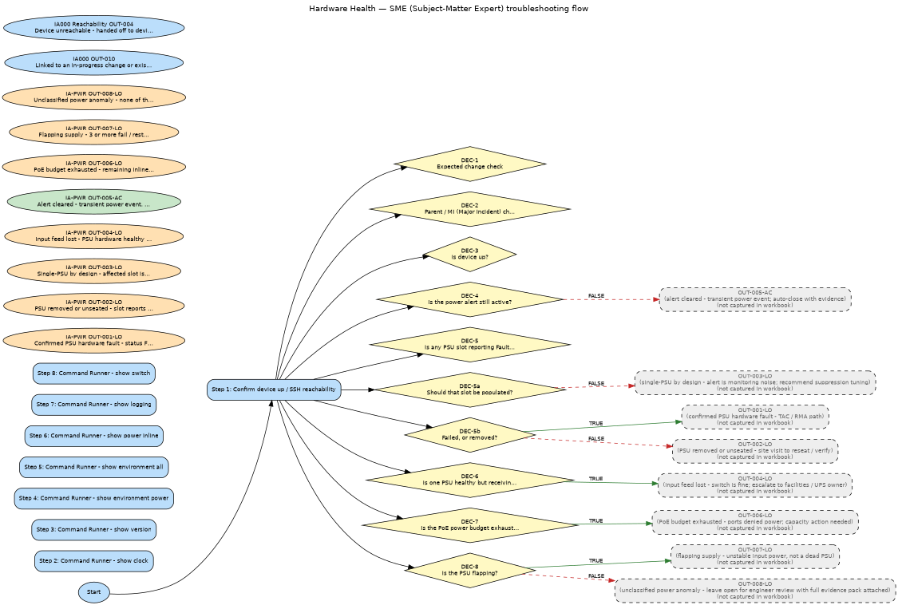
Auto-generated from workbook Sheets 2 (Decision Logic), 3 (Investigation Steps), 4 (Outcomes).

